**Console Based Banking Application**

**Objective:**

To create a console based banking application which connects to the database using SQL with java as the main language.

**Identification of Needs:**

To enhance the user experience with using the banking procedures like transactions and others.

**Platform Specification:**

**HARDWARE:**

**SOFTWARE :**

**Functional Requirements:**

1. **User account management**

Create different types of accounts: Savings and Current. To View account details, such as account type, balance, and other information. Update account information, such as contact details.

1. **Transaction Management**

Deposit and Withdraw funds from accounts. Transfer funds between accounts. To ensure thread-safe transactions using multi-threading and synchronization, so deposits and withdrawals don't conflict.

1. **Transaction History**

Save a log of all transactions to a file, allowing users to view a his their account activities. To retrieve and display transaction history for specific accounts from saved file.

1. **Database Operation Using JDBC**

Store account and transaction details in a relation Perform CRUD operations for account.

1. **Reports**

Generate reports based on the data stored a Generate various reports, such as: Account details for each customer.

**Use Case Diagram:**

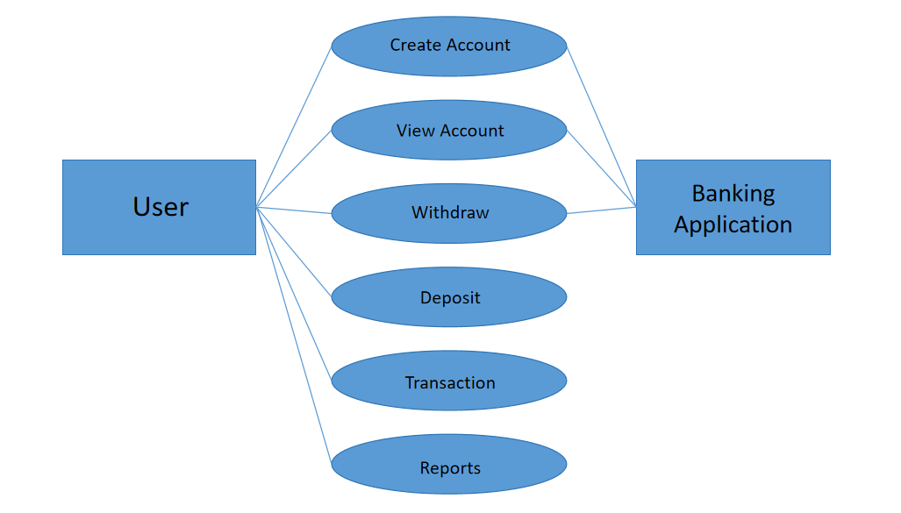

**Schema Diagram:**

**Bank:**

Stores information about the bank.

**Columns:**

Bank_Id int

Bank_Name varchar(100)

Bank_Branch varchar(100)

**Account:**

Stores account details, associated with a particular bank

**Columns:**

Account_Id int unique (PK)

Customer_Id int

Bank_Id int (FK)

AccountType varchar(50)

**Savings Account And Current Account:**

Specialized tables for different Types, inheriting from the Account Table

**Columns (Savings Account):**

Account_id INT(FK)

Interest_rate DECIMAL (5,2)

**Columns (Current Account):**

Account_id INT(FK)

**Transaction:**

Records all transaction(deposit, withdraw, transfer) Linked accounts

**Columns (Savings Account):**

Transaction_id INT(PK)

Account_id INT(FK)

Transaction_type VARCHAR (50)

Amount DECIMAL (15,2)

Transation_date TIMESTAMP

**DepositTransaction, WithdrawTransaction:**

Specialized tables for different Transaction types, inheriting from the Transaction Table

**Columns (WithdrawTransaction):**

Transaction_id INT(FK)

Withdrawal

**Schema Diagram:**

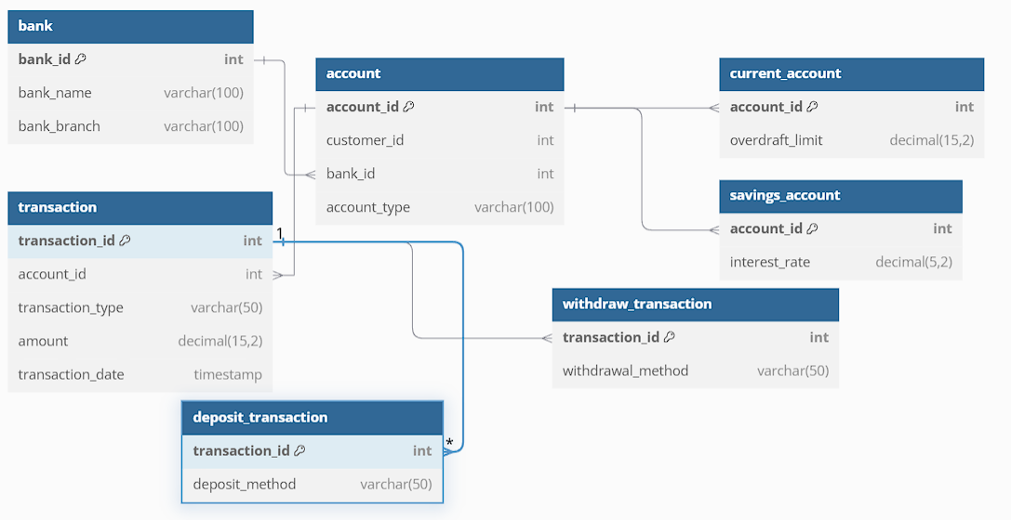

**Entity - Relationship Diagram:**

